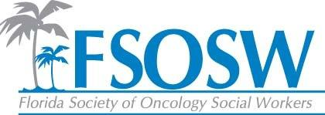
Communication Report
July 29, 2016
Chelsea Foote, LCSW

Constant Contact
- All members updated
- Membership Renewal sent February 2nd
- Call for Abstracts sent February 4th
- Save the Date sent February 9th
- Call for Abstracts sent February 24th
- Newsletter sent March 1st
- Abstract Deadline Extended sent March 17th
- Membership May sent on May 10th
- Newsletter sent June 24th
- Call for Nominations sent July 12th

Facebook
- Amy has done a great job at keeping the posts updated and they always reflect pertanent information regarding oncology social work and the FSOSW mission

Website
- Save the Date is on the conference page
- Brochure will also be linked to conference page
- Hotel booking information on conference page
- Call for Nominations/ACS Award on conference page
- Regional page not updated, due to no updates being provided on various regions and events

Updates
- I need reports from everyone to post on the website for the board to have access to
- If you need anything sent through Constant Contact or have time frames that you would like things to go out, please let me know. I can usually get that done quickly!

