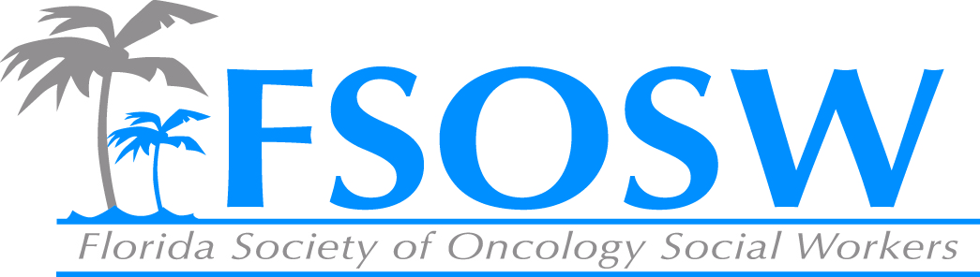

FSOSW Board Meeting
Friday, April 8, 2016

Communications Chair Report
Chelsea Foote, LCSW

- I need all reports and minutes from the previous 2 meetings, including the meeting at the conference to upload onto the Board Member section of the website.
  - Please make sure I get all reports from this meeting

- Constant Contact
  - Call for Abstracts has been sent 3 times
    - February 4th, February 24th and March 17th
  - 1st Newsletter of the year went out March 1st
  - Save the Date for the 2016 Conference was sent February 9th
  - 2nd Newsletter will go out beginning of June (promoting conference!)
  - Multiple reminders to renew membership

- Constant Contact reflects all of the current members that have renewed on the website
  - Most updated email addresses, phone numbers, and addresses are now included with each member for 2016

- Many posts on Facebook promoting membership renewal, Save the Date for the Conference, and Call for Abstracts (see Amy’s report)

