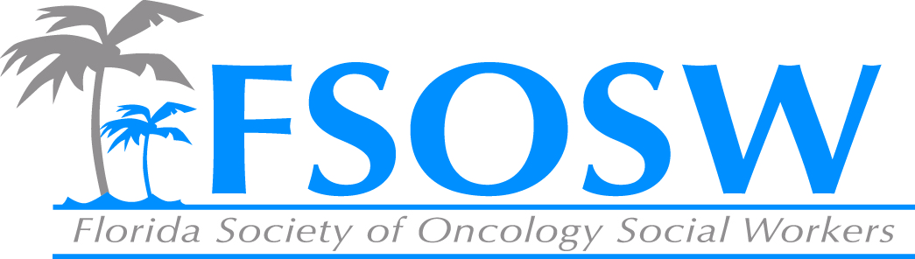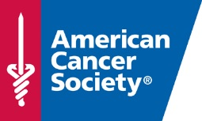
American Cancer Society Report
Florida Society of Oncology Social Work
Board Meeting
July 29, 2016

Patient Program and Services Updates
- Service Match
  - Over 50% of Road Coordinators trained
  - Goal is to complete Road Coordinator trainings by end of September
  - Success Stories

Cancer Control Updates

- New Survivorship Care Guidelines and Toolkit
  - The American Cancer Society released four sets of guidelines dedicated to promoting quality of life in the following cancer survivor population: Breast, Colorectal Head and Neck, Prostate.
  - In addition to the guidelines, ACS has released a dissemination toolkit with resources for oncology and primary care providers, cancer control and public and health professionals and patients and caregivers.
  - The guidelines and toolkit provide cancer centers evidence-based recommendations and resources for systems to develop comprehensive survivorship care strategies to address the needs of this growing population of patients.

- Colorectal Cancer Stakeholder meetings
  - Goal:
    - Encourage colorectal cancer screening efforts with a focus on the uninsured and underserved
    - Facilitate and support clinical linkages to ensure completion of the screening process from a positive FIT to the colonoscopy
  - Meeting being held this Fall: Jacksonville, Orlando and Tampa Bay Market

ACS Leadership in Oncology Social Work Award and Quality of Life Grant
- ACS Leadership in Oncology Social Work Award
  - Proposed Timeline
    - Ongoing: Promotion of Award
    - September 12, 2016: All applications/nominations due
    - September 16, 2016: Selection Committee Meeting
- Quality of Life Grant
  - For 2017, discuss shifting focus to be inclusive of all ACS Patient Programs and Services

