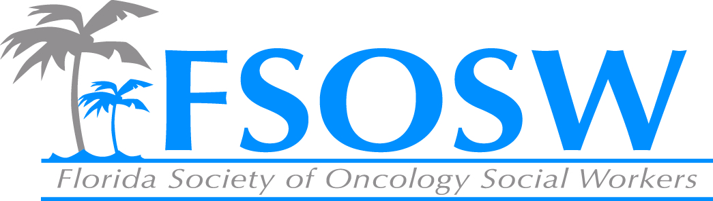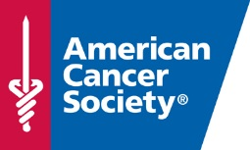
American Cancer Society Report
Florida Society of Oncology Social Work
Board Meeting
April 8, 2015

Patient Program and Services Updates
- Health Insurance Assessment Service
  - Uninsured – help investigate programs/options available & navigate marketplace
  - Insured - help those whose needs are not being met – high co-pays and deductibles
  - Transition – assist those in transition due to life changes impacting insurance status
  - http://www.youtube.com/watch?v=8oZ9v2Be0Ls
- Patient Advocate Foundation:
  - National partnership with ACS
  - Dedicated number to PAF
  - Access to care (insurance companies on insurance claims)
  - Maintenance of employment
  - Preservation of financial stability(Creditors for debt problems related to their diagnosis)
  - Co-pay Relief Program
- Transportation: New tools to increase efficiency and optimize impact
  - Road to Recovery: new tools to increase efficiency and optimize impact
    - Service Match
    - https://www.youtube.com/watch?v=liSaqOy0WgA&feature=youtu.be
  - Geomapping: Assessment Tool

Support FSOSW recruitment efforts – ongoing
- ACS staff can support awareness and recruitment efforts
  - Jackson Memorial Hospital - potential new member

ACS Leadership in Oncology Social Work Award - Ongoing
- Support awareness of ACS Leadership in Oncology Social Work Award
- ACS staff will identify potential nominees from current membership

Conference
- Promoting conference SAVE THE DATE
  - Questions about agenda and total credits for SW?
- Looking for speaker to focus on oncology social work and research perspective
- Other opportunities to support conference?!?!

