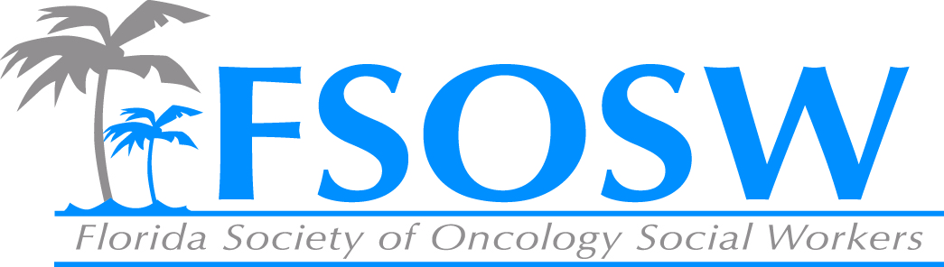

FSOSW Board Meeting
Friday, April 8th, 2016
10:00am -2:30 pm
- Call to Order/Welcome Beth Page
- Treasurer’s Report Linda Sapp
- Nominations Report Elizabeth Marshall
- Membership Report Amy Roberts
- Communications Chair Report Chelsea Foote
- ACS update Maria/Sarah
- 2016 Conference Report Linda Sapp/Bettye Bradshaw
  - Lawson Project Kimberley
- Regional Coordinators Chair Report Jennifer Maggiore
- Historian Report Chuck Miceli
- CEU Report Cara Kondaki
- Unfinished Business Beth Page
- New Business Beth Page
  - Gale Smith Scholarship
  - AOSW Conference
- Adjournment Beth Page

