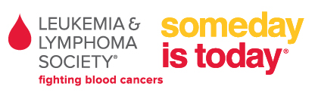
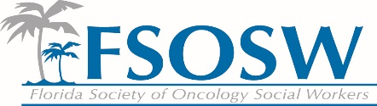
Florida Society of Oncology Social Workers (FSOSW) and
The Leukemia & Lymphoma Society (LLS)
Partnership Proposal
Each of the below listed elements and responsibilities is a menu of choices and can be modified, added to or eliminated to meet the needs of both organizations. In order for LLS to continue to provide funding to FSOSW we must agree on a mutually agreeable partnership of benefits. This would then be formalized in a statement of understanding or other non-legal document.
- LLS would sponsor the FSOSW Social Worker of the Year
- LLS would have a seat at the conference planning committee and would provide Florida Board of Nursing CE credit. The seat ideally would be filled by a member volunteer who works in collaboration with the LLS staff. Periodically LLS would be invited to provide a general session speaker at the conference.
- FSOSW could become the official partner for all of the LLS Family Support Groups in Florida, helping to recruit, train and recognize volunteers as well as assuring that each group meets all LLS requirements on a monthly basis. (see attached Family Support Group Guidelines)
- FSOSW can be a partner in our Florida Blood Cancer Conference helping to educate patients and caregivers about psychosocial and/or quality of life issues. FSOSW would receive a free exhibit table at the conference (Value $2500) and provide the speakers for one break-out session on an agreed upon topic that would be repeated twice during the day. Speakers would be recognized both by their institution and as an FSOSW member.

