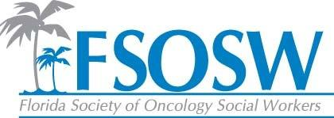

Regional Coordinator Chair Report
April 8, 2016

Tallahassee Region- Bettye is working with Jill Pait in the Tallahassee region. They will cooridnate a date for a CEU event in that region.
Jacksonville- Jennifer Maggiore and Chelsea Foote are assisting Jennifer Bailey with this region while she is out on maternity leave. There was a meeting on March 9th at a local hospice to learn about Community Care Choices. Eight social workers attended and also celebrated social work month with a breakfast waffle bar.
Orlando- Carol Duryea has just resigned as regional coordinator. Kimberly Lawson could be an option.
Gainesville- I cannot reach Amanda Biggers. I emailed her offering to assist with planning a meeting in that region.
Miami Dade Unit- Cara reported that they had two meetings during social work month.
Palm Beach Unit- Under Development

It is very difficult to get motivated oncology social workers to invest in our organziation. With strong schools of social work in Orlando, Tampa, Miami, Jacksonville, and Tallahasee, I suggest we start developing relationships with these programs and start motivating these young social workers. We have a great relationship with Dr. Paul Clark at UNF and should consider partnerships in other parts of the state.

Respectfully Submitted,
Jennifer Maggiore

