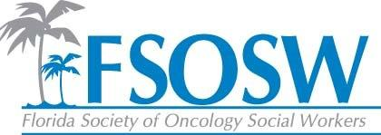

**FSOSW Regional Report**

**November 9th, 2016**

Recruited two new regional coordinators for FSOSW

1. **Central Florida Region**- Katherine Payares. LCSW Florida Hospital Celebration Health
2. **Tampa/Southwest Region**- Laurie Collins, LCSW, OSW-C Moffitt Cancer Center

**Northwest Region**- vacant

**North Florida Region**- Jennifer Bailey. No activity as she has just returned from maternity leave

**South Florida Region**- Cara and Seth are regional coordinators and have hosted 2 events with a 3rd event planned for 2016.

19 People for Domestic Violence on August 4, 2016

15 People Blood Cancer Awareness and Advocacy on September 13, 2016

Planning a Holiday event December 8th and a “Show the Love” event on February 9th.

I propose new map to post on website with updated regional coordinators. I encourage open discussion regarding delineation of regions. Please see attached map for suggestions.

I would like to continue to grow the regions and provide support to the regional coordinators. This is one of our most valuable resources to members. AS we compete with online education, robust AOSW membership benefits, regional meetings and support that is relevant and timely is vital. I cannot attend Board Meetings in 2017 but I committed to supporting this position.

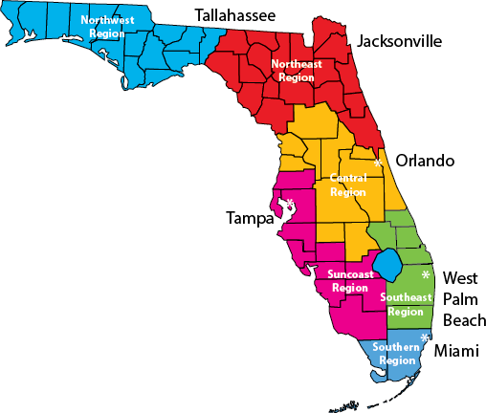

I