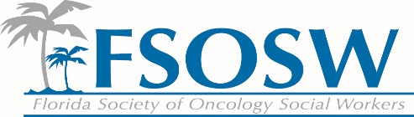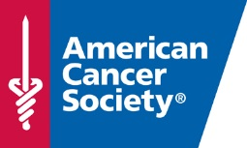
American Cancer Society Report
Florida Society of Oncology Social Work
Board Meeting
November 9, 2016

Patient Program and Services Updates
- Transportation: Service Match
  - All volunteer coordinators have been trained and are utilizing the new tool
  - As result, we have seen increase the number of patients served

Colorectal Cancer 80% by 2018 Efforts
The Florida Division held four Colorectal Cancer Regional Stakeholder meetings (Roundtables): Miami (September 24, 2015 and June 8, 2016), Central Florida (September 28, 2016), Tampa Bay (October 27, 2016) and one is scheduled to be held in Jacksonville (December 7, 2016). The primary goal of the meetings is to share information, exchange ideas and highlight promising practices from local health systems including hospital networks, community health systems, and health plans. Each meeting provided an opportunity for collaboration and networking among various stakeholders throughout the region to coordinate efforts for achieving “80% by 2018” and to reduce late stage diagnoses.
Key priority themes were identified at the meetings, which the stakeholders committed to address collaboratively. These include:

- Business Case for early detection and reducing financial burden for community partners offering screening opportunities
- Outreach and Navigation throughout the entire colorectal cancer continuum of care.
- Creation of a colorectal cancer repository of screening, diagnostic, and treatment resources in each area
- Education to healthcare professionals regarding screening, quality and resources.

To date, the Colorectal Cancer Regional Stakeholder meetings have resulted in increased collaboration amongst key health systems partners, addressing the identified priority themes.

