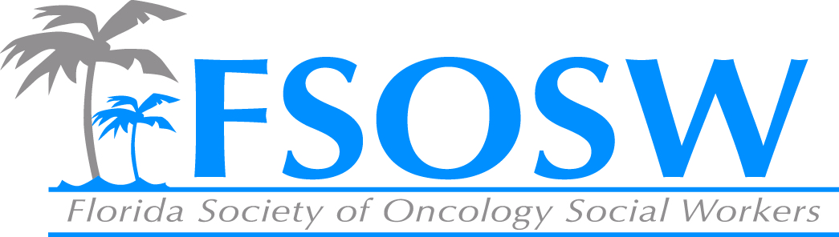

FSOSW Board Meeting
November 9th
9:00am -12:00 pm
- Call to Order/Welcome Beth Page
- Conference report Linda Sapp
- Treasurer’s Report Linda Sapp
- Nominations Report Elizabeth Marshall
- Membership Report Amy Roberts
- Communications Chair Report Chelsea Foote
- ACS update Maria/Sarah
- I Can Cope Christina Austine-Valere
- Regional Coordinators Chair Report Jennifer Maggiore
- Historian Report Chuck Miceli
- CEU Report Cara Kondaki
- Unfinished Business Beth Page
  - Gale Smith Scholarship
  - LLS proposal
- New Business Beth Page
- Adjournment Beth Page

