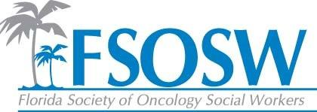
Communication Report
November 9, 2016
Chelsea Foote, LCSW

Constant Contact
- All members updated
- 75 members in constant contact and on the website
- Emails sent to membership about voting, conference, and nominations

Facebook
- Amy has done a great job at keeping the posts updated and they always reflect pertanent information regarding oncology social work and the FSOSW mission

Website
- Regional page not updated, due to no updates being provided on various regions and events
- Conference page was updated to reflect new and pertanent information

Updates
- I need reports from everyone to post on the website so the board can have access

Newsletter
- A newsletter will come out after the conference
- If anyone has anything specific they want added, please let me know

Thoughts for next year:
- Constant Contact is a great way to reach our membership. I would like to work with everyone to create a timeline for announcements and emails that need to go out throughout the year. This will make the process more streamlined and ensure that everything goes out to the membership in a timely manner.

