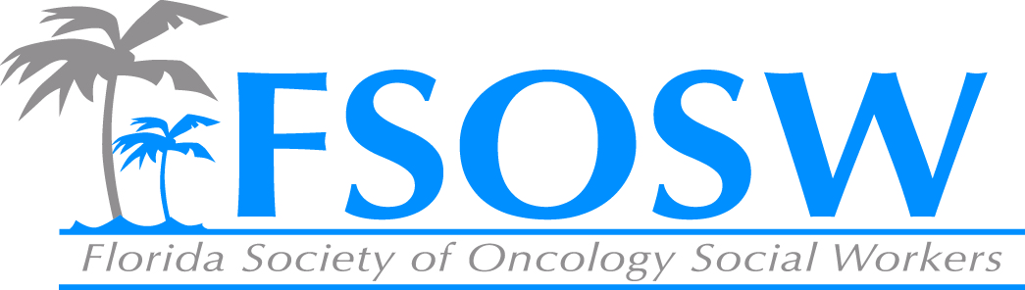

FSOSW Board Meeting
Friday, April 4^{th,} 2014
10am to 3pm

- Call to Order/Welcome Jennifer Maggiore
- Treasurer’s Report Linda Sapp
- Membership Report Amy Roberts
- Communications Chair Report Beth Page
- 2014 Conference Report Mary Turney
- Nominations Report Christina Austin Valere
- Regional Coordinators Chair Report Christina Austin Valere
- Historian Report Bettye Bradshaw
- CEU Report Cara Kondaki
- Unfinished Business Chuck Miceli
- New Business Jennifer Maggiore
- Adjournment Jennifer Maggiore

